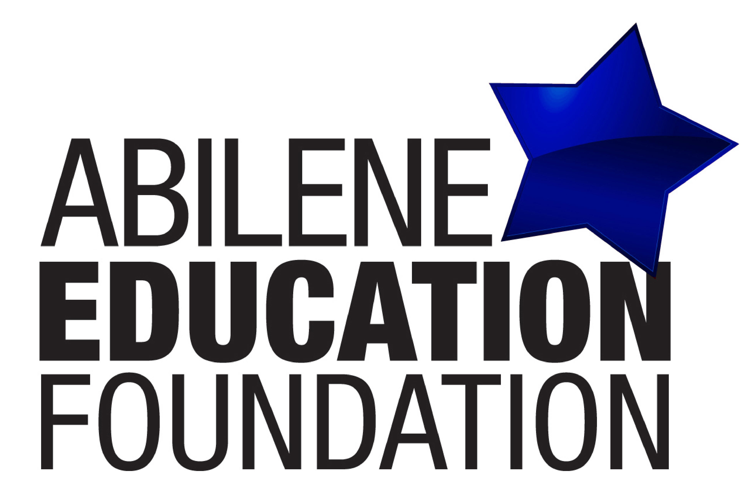

Abilene Education Foundation
Board Meeting Agenda

Wednesday, August 20, 2014
11:30-1:00 PM
Crockett Room
AISD Administration Building, 241 Pine Street

- Call to Order – Buddy Napier
- Approve Consent Agenda
- Minutes of the May 21, 2014, Board Meeting
- Financial Report – January – July 2014

- Financial Highlights – May, June, July 2014 / Linda Dubocq
- Introduce Guests / Guests Reports
- Robin Swartz / Science Teacher / Clack Middle School
- Kara Schlentz / P. E. Teacher / Martinez Elementary

- Superintendent’s Report
- Fiscal (or) Program Sponsor Services Policy / Committee Recommendation / Kevin Campbell
- Committee Updates
A. Payroll Deduction Campaign Report / Kaye Price-Hawkins

B. TLC Committee Report / Angie Wiley and Tiffany Lamb

C. STAR Teacher Grants / Mike Thomesen

- Scholarship Update / Kay Hartgraves

- COOL Report / Dustin, Amanda, Key and Christine

- ACT Grant Report / Jason Darby

- Online Auction Report / Sue Smith

- Executive Director’s Report
- Other Business
- Adjourn AEF Board Meeting Calendar
September 17, 2014 / October 15, 2014 / November 19, 2014 / December 10, 2014
Benefiting the Abilene Independent School District

