**Abilene Education Foundation**

**Minutes of the Board of Director’s Meeting**

**Wednesday October 16, 2013**

Attendance Board Members: Marci Braden, Terry Bull, Jason Darby, E. B. Dotson, Jay Hardaway, Jennifer Harper, Kay Hartgraves, Laura Moore, Buddy Napier, Roland Orr, Linda Roark, Angie Wiley

Advisory Board Members: Dr. Audra Ude, Mike Dudley, Judy Godfrey, Nita Slaton, Sue Smith, Nell Sims,

Kim Snyder

Guests: Christine Curtis-Carr, Linda Dubocq, Paula Dickie

Executive Director: Jean McMillon

President Napier called the meeting to order at 12:00 p.m.

E. B. Dotson made the motion to approve the minutes from the September meeting. Kay Hartgraves seconded the motion, and the minutes were approved as presented.

**Superintendent’s Report**

Dr. Audra Ude gave an update on curriculum issues in the absence of Dr. Burns. Several curriculum writers have been hired to rewrite lessons due to the loss of C-Scope. In her brief tenure in AISD, she reported teachers are doing an outstanding job with the resources that are available. She has found the teachers in the district to be very caring of their students.

**Financial Report**

E. B. Dotson, treasurer, went over the highlights of the September finance report. The following financial documents were presented: Financial Highlights September 2013; Statement of Financial Position as of September 30, 2013; Statement of Activities September 2013; Statement of Activities – Actual vs. Budget January through September 2013; and Net Assets and Class Reconciliation September 30, 2013. Copies of the above-mentioned financial documents are attached to these minutes.

Marci Braden made the motion to approve the financials as presented. Roland Orr seconded the motion and the motion passed.

**Audit Report**

Treasurer E. B. Dotson shared the audit committee had a phone conference with the auditor last week. No problems were found with the audit. The committee, at the suggestions of the auditor, will change the AEF staff’s debit cards to credit cards in an effort to avoid identity theft and add another level of internal control. The audit was very clean and the letter to the Board found no problems. President Napier thanked Mr. Dotson and Linda Dubocq for all they do to ensure everything is in order. Mr. Dotson added with the large number of donors the bookkeeping is a very complicated process.

Jay Hardaway made the motion to accept the audit as presented; Laura Moore seconded the motion, and the motion passed.

**Strategic Plan**

Roland Orr reported the Strategic Plan is a working document and should be revised and altered as the needs and goals of the district and AEF change. He asked members to review the weaknesses and send suggestions to Ms. McMillon. The new document will be voted on at the November meeting.

**Committee Updates**

TLC

Angie Wiley, chair, informed members that the Science and Math nomination process is online this year and is already up and ready to go. Several ads have appeared in the Abilene Reporter-News asking community members to make nominations. Ms. Wiley is working with the newspaper to get an article with background and information on the awards. She is also working to finalize the selection committee. This year’s event will be underwritten by the Abilene Teachers Federal Credit Union. Fliers will go home with AISD students this month and will be included in the annual fund letters that mail on November 22.

STAR Teacher Grants

The STAR Teacher Grant reception will be on Monday, November 11, at 5:00 p.m. in the atrium area at One AISD Center and recipients will be recognized at the AISD Board of Trustee meeting at 5:30. Invitations will be mailed at a later date. The Prize Parade was a huge success! Martinez Elementary had 10 grants this year and an assembly was held at the school to give out the grants on September 22.

Payroll Deduction

Christine Curtis-Carr, co-chair, reported 10 schools had 100% participation—Abilene High, Austin, Bowie, Bonham, Holland, Lee, Long, Planetarium, Taylor, and Thomas. This is the largest amount ever! On November 4 those campuses will receive prizes and treats. Jackson Elementary had 90% participation and they will also receive prizes. At the STAR Teacher Grant reception on November 11, names will be drawn to receive ten 32” flat screen television sets donated by Robert Briley—Aarons. Due to a new Employee Scholarship Fund set up at Abilene High and Cooper High schools, there was a large increase in participation from the high school campuses.

This year’s Payroll Deduction Campaign brought in a total monthly donation of $3,353.34 and total one-time donations of $6,132. Both of these amounts are large increases over last year. A total of $1,187.84 in new monthly donations was received. The employees of AISD have been very generous this year.

COOL

Christine Curtis-Carr gave a COOL report with the following highlights.

* The scholar-stick competition is ON! The scholar-stick is like a spirit stick, but will be awarded to the high school with the most scholarship dollars awarded by the end of the school year. AHS COOL students are already receiving initial acceptance letters and have reported over $250,000 in scholarship offers. Amanda Hothan said she was confident it would be a drop in the bucket and that AHS COOL will take the scholar stick this year.
* At Cooper, Tyana Ellis (a COOL participant) was awarded the Outstanding National Achievement Scholarship program. She scored in the top 3% of more than 160,000 African Americans who took the test. LaQuiera Gantt also met with teens at the Dyess Youth Center College Fair. She wants to personally thank everyone who signed up for the speed mentoring on Oct. 29th.
* At ATEMS, COOL started COLLEGE WEEK where once a month McMurry, TSTC, ACU, and HSU will come to campus and spend two hours of their day talking with students, doing presentations, and helping students with the college process.
* At WCE, Will encouraged two students to make the jump for dual credit. They are enrolled and COOL is offering them as much support as possible. They are the first students at WCE to enroll in a dual credit course.
* Between the four counselors, presentations to over 100 classes have already been made in Abilene ISD from 8th to 12th grades from Mann, Clack, AHS, CHS, WCE and ATEMS. Ms. Curtis-Carr is currently working with a teacher at Jane Long to create a pilot program called Horns Headed to College. More updates will follow soon, but the parent meeting earlier this month was very well attended. All the students enrolled will be the first ones in their families to enroll in college. At the middle schools and for select 9th and 10th grade classes, Ms. Curtis-Carr is presenting a series of college related workshops including Create Your College vision boards, Personal Values and Goal Setting, and Rocketing Past College Admissions.
* The college tours are off and running! There are many changes to admissions that we anticipate seeing over the next couple of years. Our students are enjoying their experiences.
* The college fair in October had approximately 700-800 people in attendance, including some younger students from the surrounding region. P-16 Council provided the GenTx bags again this year. There were wonderful presentations on changes to the NCAA eligibility center, financial aid and, of course, scholarships by Nita Slaton.

Online Auction

Sue Smith, chair, informed the group of a new fundraising event—the Online Auction. The committee has had one meeting and still has lots of work to do. A pilot auction was held the weekend of the AHS/CHS football game and $400 was raised. The committee will meet again and set up another auction for the spring.

Executive Director Report

Ms. McMillon reported the following items to the board:

* Roland Orr, chair of the nominating committee, will begin the process to search for new members for the board. Anyone with suggestions please let Mr. Orr or Ms. McMillon know.
* AEF will be highlighted at this year’s Community Foundation annual luncheon on November 6. This is a great opportunity for AEF.
* The Annual Fund Drive is underway. Board members will be asked to come and sign/write notes on the letters prior to the mail out.
* STAR Teacher Grant reception will be held November 11.
* AEF has received the OK to pursue a grant for the framing for the Young Masters Juried Art Exhibit in April 2014.
* The Cajun Fest is scheduled for April 10, 2014. Work has already begun. Bird Thomas, ACAC, has completed the paperwork to have the streets closed!!
* Jason Darby, chair of the Achievement Grants, reported the name has been changed to ACT (Achievement, Creativity, and Technology) Grants. The last cycle for this year will end in November.

The meeting was adjourned at 1:05 p.m.

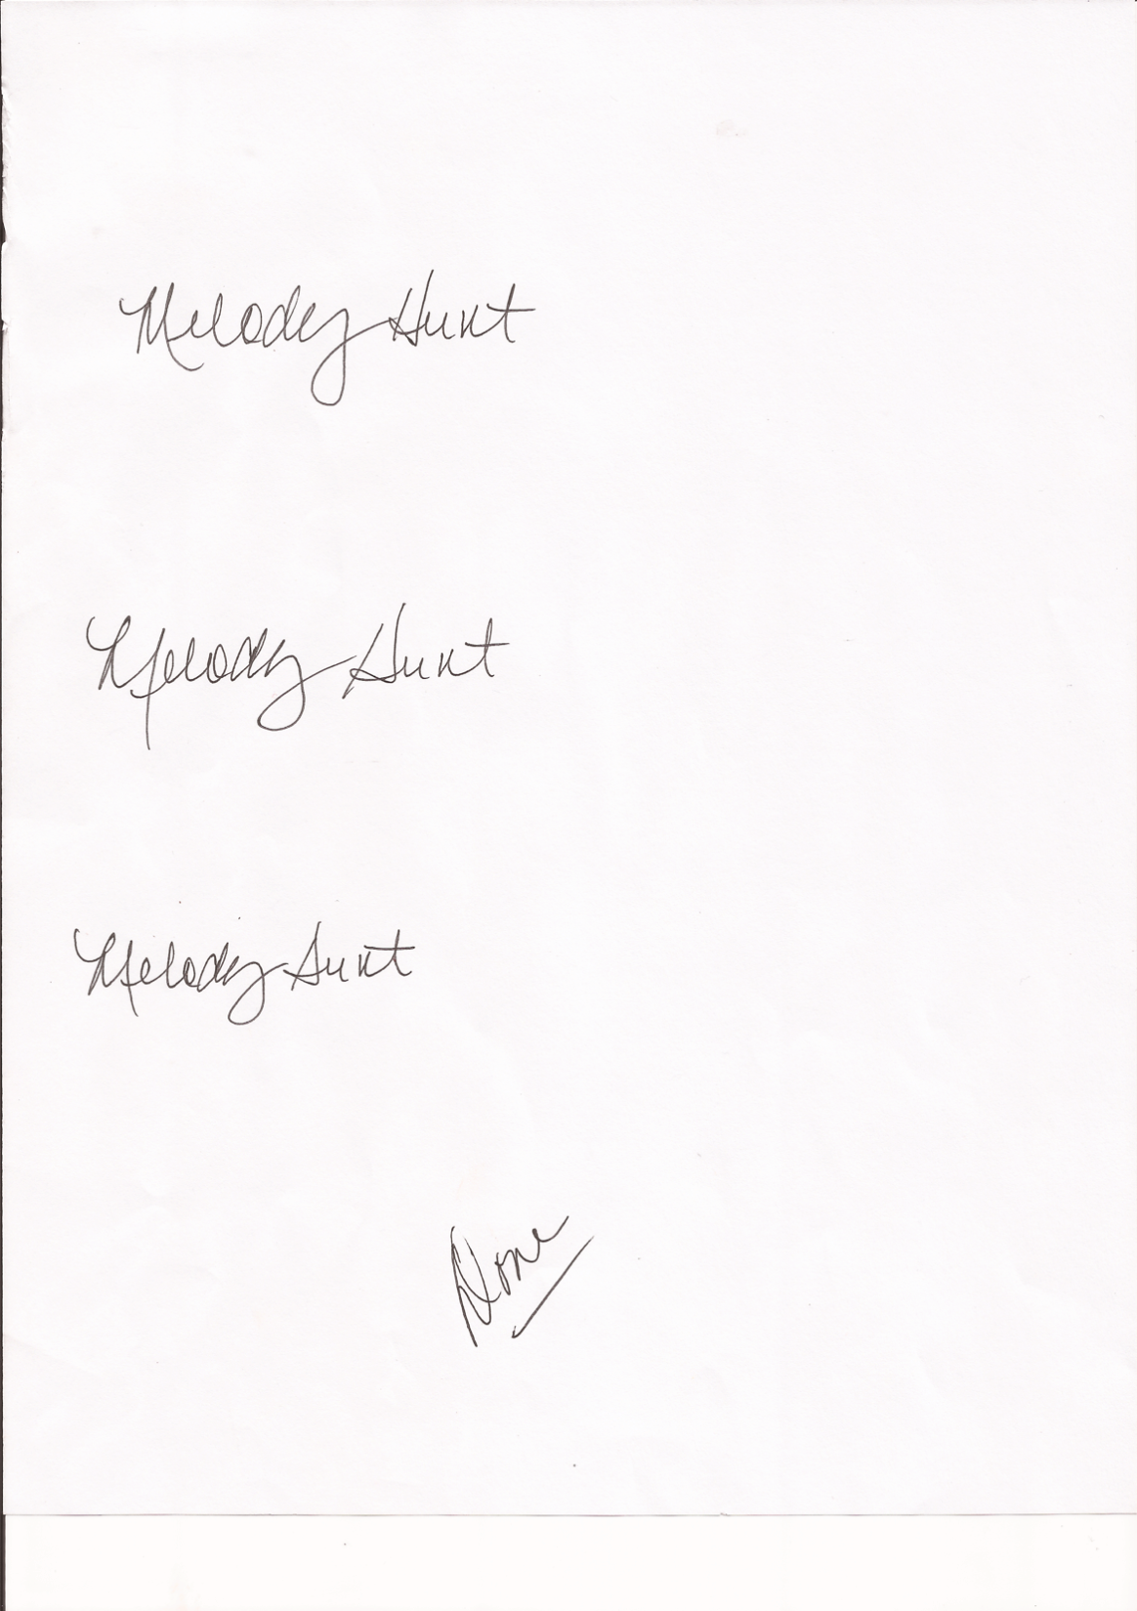Respectfully submitted,

Melody Hunt (via Paula Dickie)