**Abilene Education Foundation**

**Minutes of the Board of Director’s Meeting**

**Wednesday May 15, 2013**

Attendance Board Members: Marci Braden, Terry Bull, Lisa Chavez-Owens, E. B. Dotson, Mike Dunnahoo, Jennifer Harper, Kay Hartgraves, Laura Moore, Buddy Napier, Roland Orr, Randy Pool, Linda Roark, Nancy Roberts

Advisory Board Members: Carolyn Beckham, Lisa Harp, Sue Smith

Guests: Dr. Cathy Ashby, Christine Curtis-Carr, Linda Dubocq, LaQuiera Gantt, Amanda Hothan, Will Medina

Executive Director: Jean McMillon

President Napier called the meeting to order at 12:04

E. B. Dotson moved to approve the minutes from March 20, 2013. Roland Orr seconded the motion. Motion passed.

**Financial Report**

The following financial documents were presented: Financial Highlights March – April 2013; Statement of Financial Position as of April 30, 2013; Statement of Activities March through April 2013; Statement of Activities – Actual vs. Budget January through April 2013; and Net Assets and Class Reconciliation April 30, 2013. Copies of the above-mentioned financial documents are attached to these minutes.

Mr. Dotson reported the audit bid information had been disseminated and one bid from Condley and Co. had been received. He informed the AEF Audit Committee that the bids received would be sent to them soon. Executive Director Jean McMillon pointed out in response to a question from Randy Pool that the $4,400 received thus far from AISD employee insurance rebate would be used to reimburse AEF for the TV ads done for AISD regarding open enrollment and AISD’s accomplishments. Any overage would go to the STAR Grant program. Mr. Dotson also reported that endowment monies for one of our scholarships shown in the report will not be used until the following year at which time a new scholarship honoring a retired teacher will be announced and given. Kay Hartgraves moved to accept the financial reports as presented; Mike Dunnahoo seconded the motion. Motion carried.

**Superintendent’s Report**

Dr. Cathy Ashby reported that test scores received thus far were good with the exception of fifth grade math, which was slightly down. She also noted that AISD was on track to reach record National Merit Scholarship numbers again. Dr. Ashby thanked AEF for allowing AISD to do so many things above and beyond.

**Committee Updates**

Young Masters

Lisa Chavez-Owens, chair, informed the board that Young Masters was a success with $8,500 in scholarships given this year versus $5,000 given in 2012. She reported that next year’s date had been set, April 7, 2014, and that it would now be held at The Grace Museum annually. She thanked AEF board members who had raised money for Young Masters.

Cajun Fest

Linda Roark reported that Cajun Fest netted approximately $50,000 and that in a post-Cajun Fest meeting, suggestions to further streamline the process had been collected. Carolyn Beckham stated that using volunteers from the AHS Class of 1958 in the VIP tent was a good way to involve alumni in fund raising functions. Executive Director Jean McMillon noted that she and Christine Curtis-Carr had participated in Abilene Christian University’s National Public Radio fund raising drive, offering two 2014 Cajun Fest tickets which had been “purchased.”

TLC

The Teachers in the Limelight ceremony was held Monday, April 29, at Abilene Country Club with donor, Edwin Jr. and Colleen Jennings’ daughter and son-in-law in attendance. Kay Hartgraves, TLC Committee member reported on the ceremony and of the appreciation expressed by AISD’s administrators and teachers for this wonderful acknowledgement. She expressed thanks to board and TLC committee member, Randy Pool and his wife, Marianne, for furnishing dinner for the event. Jean McMillon reported that AISD may be willing to share in expenses for the evening. Marci Braden announced that she and her family would be sponsoring a new scholarship in the coming year in memory of her sister, Myra P. Martinez, a former AISD teacher.

Scholarship Committee

Kay Hartgraves, chair, reported that a record number of applications had been received, 104 total. She also told the board that thirty-four scholarships were given for a total of $46,200. Of that amount, $28,200 was donor directed. Including Young Masters, AEF gave a total of $53,950 in scholarships for the 2012-2013 school year. The awards ceremony and reception will be May 20 at Frontier Texas. She thanked board member, Mike Dunnahoo, for underwriting the reception. A reader’s meeting has been set for June 11 in her office to discuss streamlining the application evaluation process.

COOL

Christine Curtis-Carr asked COOL staff and counselors to share stories of their experiences during the school year. Will Medina reported that the first graduating class at ATEMS (74 students) would receive $1.1 million in scholarships. Christine Curtis-Carr told the board about Camp COOL, an 8th grade leadership camp to be held in June at a retreat on Lake Brownwood. The camp will focus on achieving and maintaining good grades early, and students will learn about the COOL program and how to be successful in school life.

**Executive Director Report**

Ms. McMillon reported the following items to the board:

* Volunteer of the Year is Linda Roark.
* The Star Teacher Grant Award cycle was announced and new specifics on the 21st Century Learning Projects are included. AEF will award $50,000 in grants this year to AISD teachers. The Payroll Deduction luncheon has been held with Kaye Price-Hawkins and Christine Curtis-Carr using “Helping Hands” as the theme. School liaisons were re-instituted this year as the favored campus contact point by administrators. Robert Briley will donate ten television sets to the payroll deduction drawing.

**Other Business**

Board members were shown a video equating their fund-raising “race for excellence” for AISD to the horse racing world’s race for the coveted Triple Crown. A bouquet of the flowers associated with each of the three races which make up the Triple Crown (Kentucky Derby, Preakness, and the Belmont Stakes) was presented to committee chairs Lisa Chavez-Owens, Angie Wiley, and Linda Roark.

Randy Pool reported to the board on P-16’s success in passing out the Kindergarten Readiness Activity Book which AEF helped sponsor. He also shared his appreciation for the participation in the girl’s graduation project, which allowed girls to shop for prom dresses and accessories at the Mall of Abilene after being treated to lunch at Chili’s. He thanked AEF board members for their individual contributions to the project.

The meeting was adjourned at 1:00 p.m.

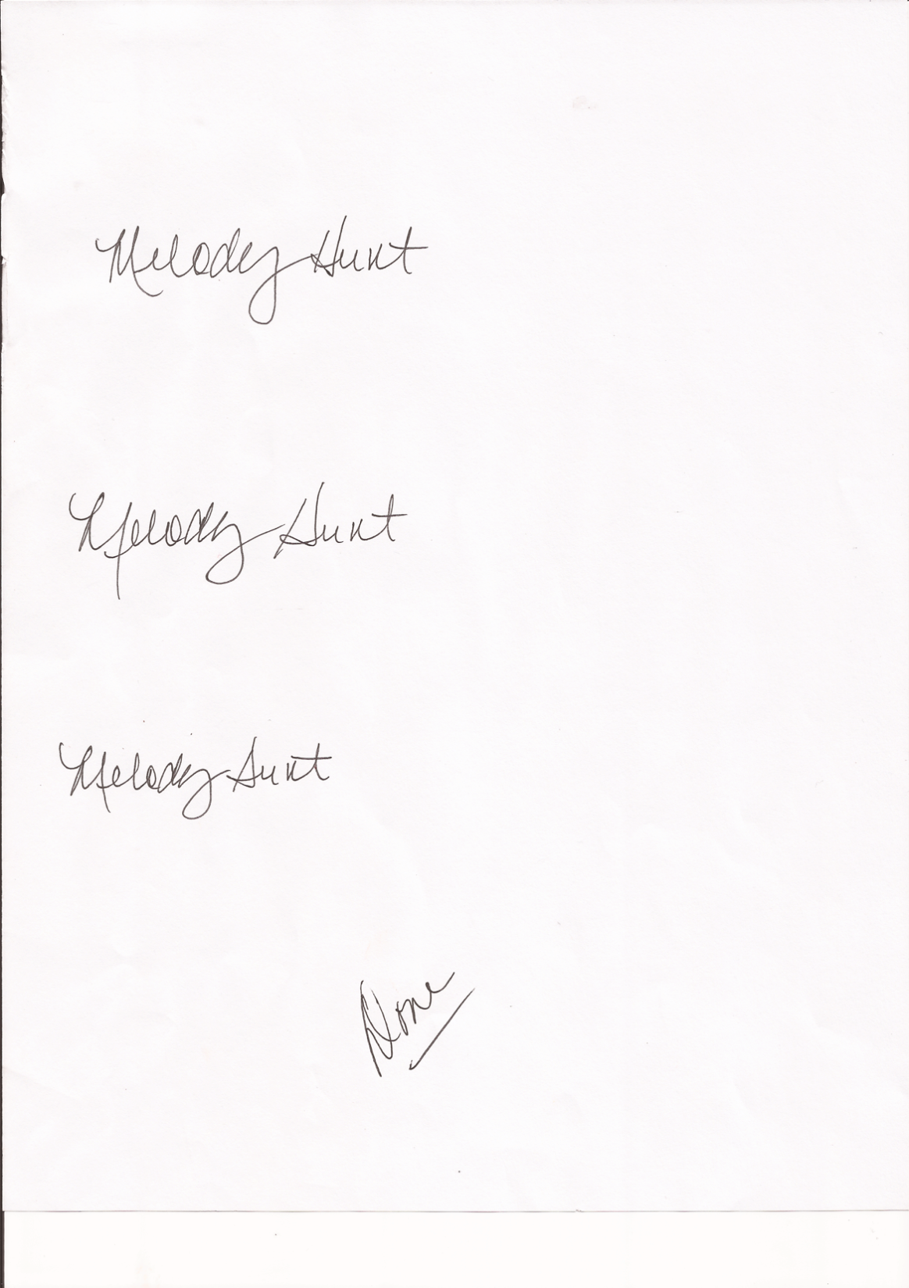Respectfully submitted,

Melody Hunt (via Sue Smith)