**Abilene Education Foundation**

**Minutes of the Board of Director’s Meeting**

**Wednesday August 21, 2013**

Attendance Board Members: Marci Braden, Terry Bull, Lisa Chavez-Owens, Jason Darby, E. B. Dotson, Kay Hartgraves, Melody Hunt, Laura Moore, Buddy Napier, Roland Orr, Randy Pool, Linda Roark, Nancy Roberts

Advisory Board Members: Heath Burns, Mike Dudley, Judy Godfrey, Nita Slaton, Sue Smith, Kim Snyder

Guests: Angie Henley, Victoria Spangler, Christine Curtis-Carr, Amy Castleberry, Linda Dubocq, LaQuiera Gantt, Amanda Hothan, Will Medina, Paula Dickie

Executive Director: Jean McMillon

President Napier called the meeting to order at 11:50.

Minutes from the May meeting were approved as presented.

**Superintendent’s Report**

Dr. Heath Burns gave a brief state-of-school report. He shared that the AISD Board of Trustees is expected to call a bond election at their next meeting. Since the bond has not been called, he could not provide the specifics at this time. He requested that the AEF Board call a special meeting to allow him to provide details and answer questions. Dr. Burns would like to get the correct information out and to answer any questions that may arise. He encouraged everyone to vote their conscience once they have had a chance to process the needs of the district.

STAR Teacher Grant Reports

Victoria Spangler, Young Audiences director, has received several STAR Teacher Grants over the past few years for after school projects at various campuses across the district. She shared how the monies were used and what a great experience it was for the students, teachers, and for Young Audiences.

Angie Henley, AISD 7th grade teacher, received a STAR Teacher Grant last year—Flip the Classroom. She shared how the grant monies allowed her to purchase equipment to engage her students in learning.

Both STAR Teacher Grant recipients thanked the AEF Board for allowing AISD students to have these experiences that would not happen without available grant monies.

Financial Report

The following financial documents were presented: Financial Highlights May-July 2013; Statement of Financial Position as of July 31, 2013; Statement of Activities May through July 2013; Statement of Activities – Actual vs. Budget January through July 2013; and Net Assets and Class Reconciliation July 31, 2013. Copies of the above-mentioned financial documents are attached to these minutes.

E. B. Dotson provided a brief review of the Financial Highlights since May. The financials were approved as presented. President Napier thanked Mr. Dotson and Linda Dubocq for all of their hard work in keeping AEF records accurate and in line with all government regulations.

Committee Updates

Payroll Deduction

Christine Curtis-Carr, co-chair, showed the video for the Payroll Deduction Campaign. All AISD employees were shown the video once they returned to work in August. Kaye Price-Hawkins, co-chair, presented this video the new teachers in the district at the New Teacher Orientation. During the two days of the New Teacher Orientation, $225 per month of new money was raised! This is a first-time occurrence! Ms. Price-Hawkins purchased screen cleaning cloths for the payroll deduction donors and one was given to each AEF Board member in attendance. Ms. McMillon thanked Ms. Price-Hawkins and Will Medina for a job well done on the Payroll Deduction Campaign video.

TLC

The 2013-14 Teachers in the Limelight Celebration is scheduled for Monday, April 28, 2014, at Abilene Country Club. Angie Wiley, chair, and Ms. McMillon have met with Dave Sledge, Abilene Reporter-News, and he has agreed to continue the same coverage provided last year for the TLC and the Cajun Fest.

Scholarship Committee

Kay Hartgraves, chair, reported Dr. Bracken Kolle, AHS Class of 1993, has set up the Royce Curtis Excellence in Education Endowed Scholarship in honor of Royce Curtis. This was announced at the class’ 20th high school reunion in July. Dr. Kolle has set up the endowment with an initial gift of $25,000 and has agreed to match (up to another $25,000) any other gifts received.

The AHS Class of 1958 will have their 55th reunion this year and have already collected almost $2,000 for the AHS Alumni Scholarship Endowment.

This year there was an abundance of scholarship applications. Under the leadership of Ms. Hartgraves, the committee has met and is working on ways to streamline the 2014 selection process. She thanked the volunteers who read this year and asked for additional help in 2014.

The Abilene High School and Cooper High School employees are raising funds (through payroll deduction) for a scholarship at each of the campuses this year. Will Medina has begun the Rising Phoenix Award Scholarship for an ATEMS student. Ms. Hartgraves thanked Ms. Curtis-Carr for her assistance in making this happen.

Audit

Treasurer E.B. Dotson stated the audit has been completed by McElroy and Company. The committee will meet via conference call to complete the process. He was pleased and reported that all had gone smoothly. Details will be presented at a future meeting.

COOL

Christine Curtis-Carr gave a COOL report with the following highlights.

* COOL Annual Report was completed and mailed in July.
* The first ever CAMP COOL was a huge success. Twenty-seven 8th graders went to Lake Brownwood for four days. Their camp centered on the book

*7 Habits of Highly Effective Teens* as the core of their studies.

* COOL counselors had a goal to reach 500 students last year. They accomplished this goal with a total of 541 students served!
* Terry Johnson, Ads4Next director, helped his students raise over $10,000 for scholarships. Many of the COOL students participated in this endeavor.
* Holland Medical High School students will take a college tour to the Health & Science Center at Texas Tech University this year.
* Deaf Ed students will take a tour to a college for the deaf.
* P-16 Council had a FAFSA night.
* COOL sent out a letter to CAMP COOL participant parents thanking them for allowing their children to attend the camp.
* Community Foundation of Abilene sent a letter to Dian Graves Owen Foundation and the Shelton Family Foundation thanking the COOL counselors for working with the student scholarship applicants. The CFA stated a remarkable difference in the applications was noted due to the involvement of the COOL counselors.
* AEF will be highlighted at the CFA luncheon in November.
* Will Medina has revamped the AEF website and created a COOL website. He will give more information at the September meeting.

Terry Bull, retired Abilene High School principal, emphasized the work of the COOL counselors and the impact they have made on the high school campuses. They work with over ½ of the seniors in the district.

Executive Director Report

Ms. McMillon reported the following items to the board:

* Melody Hunt has agreed to pay for an intern in the fall.
* Lisa Chavez-Owens has obtained Ron Cheek as the judge for the 2014 Young Masters. Ms. Chavez-Owens and Ms. McMillon are working on a grant to cover the costs for the framing of the artwork.
* Sue Smith has returned to Abilene and will chair the committee for an online auction fundraiser. Volunteers are needed with this fundraiser.
* The final cycle of the Achievement Grants ends on Friday. To date, $11,000 has been dispersed through this grant. The committee is in the process of find-tuning the criteria and will be meeting soon.
* Laura Moore asked for funding again this year for the Grace Art Project. Last year AEF gave $5,000 and she is asking for this amount again this year. Kay Hartgraves made the motion to give $5,000 to the Grace Art Project. Melody Hunt seconded the motion. Motion passed. Mr. Dotson will include this in the budget preparations that will begin soon. Mr. Pool suggested working with other foundations/non-profits to fund this project for a longer term.
* $8,100 has been dispersed in GIFT Grants this year to date. Ms. McMillon thanked Mike Dudley and his mother, Pat, for their support in this endeavor.
* AEF hosted a presentation for the IRC (International Rescue Committee) families to help with acclimation into the Abilene ISD schools.
* Ms. McMillon and a few other AEF board members and staff met with Dr. Ude, new Associate Superintendent for Curriculum and Instruction.
* Ms. McMillon encouraged everyone to “Plug In and Power Up!” for the upcoming school year.

The meeting was adjourned at 1:15 p.m.

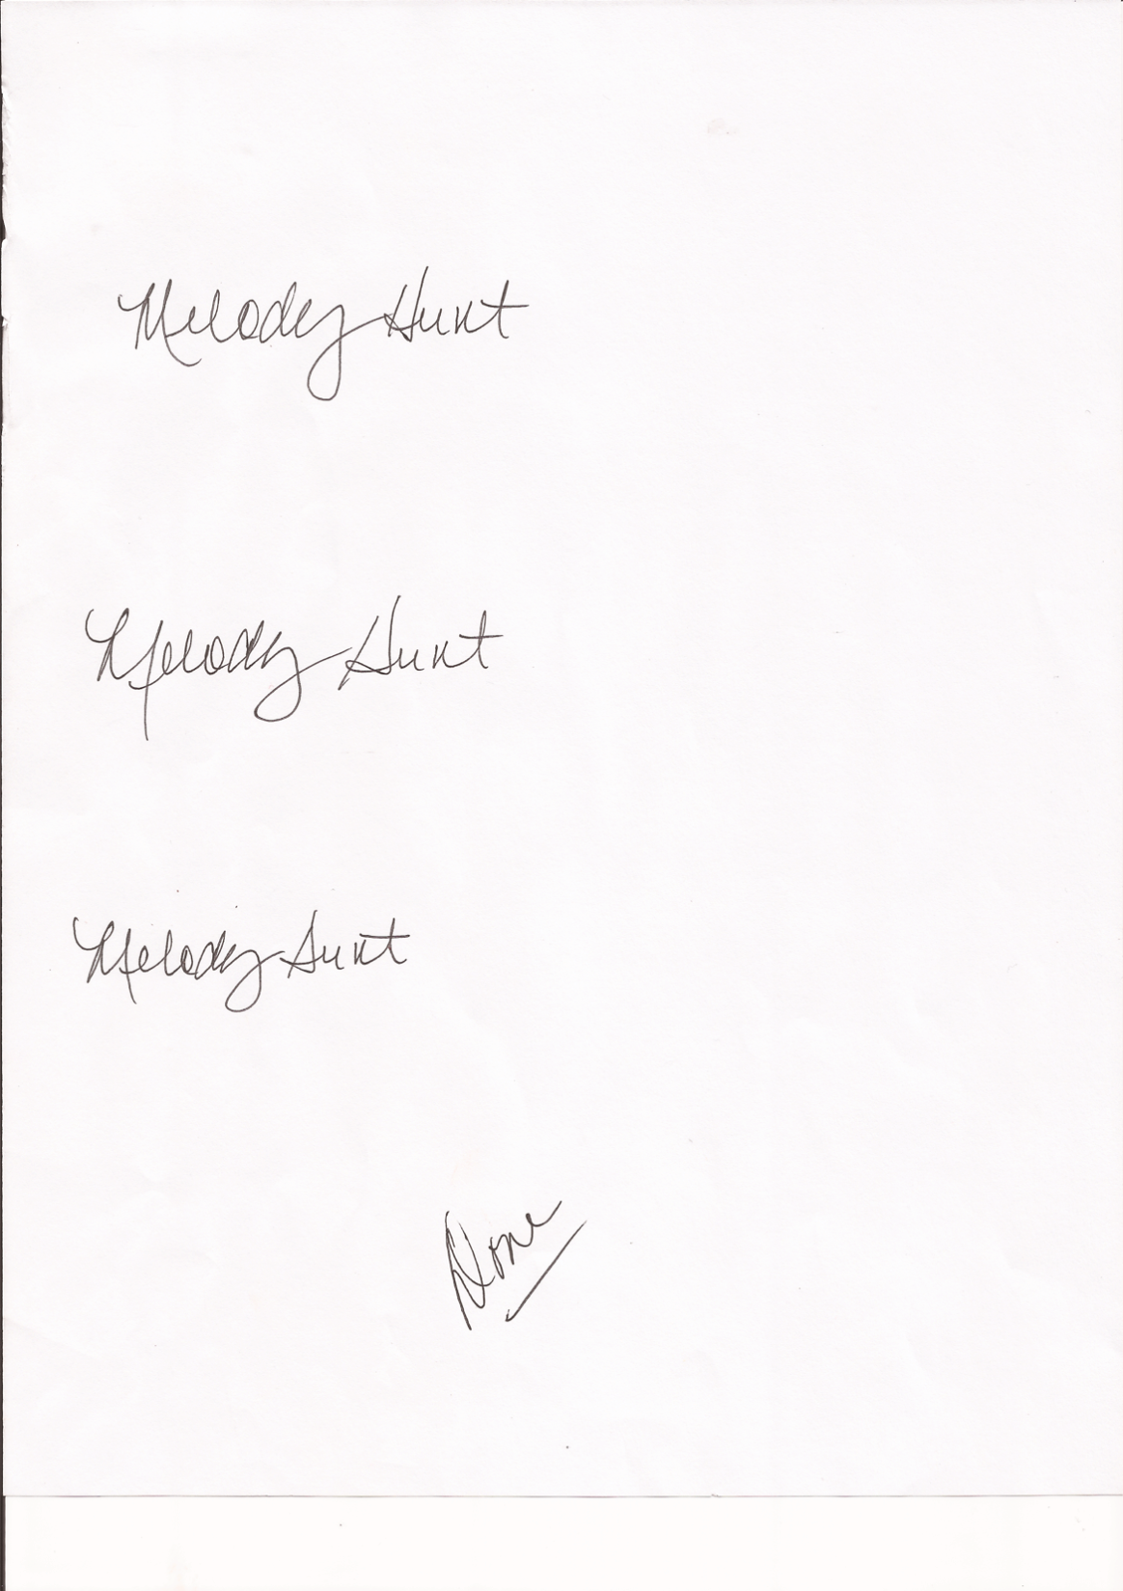Respectfully submitted,

Melody Hunt (via Paula Dickie)