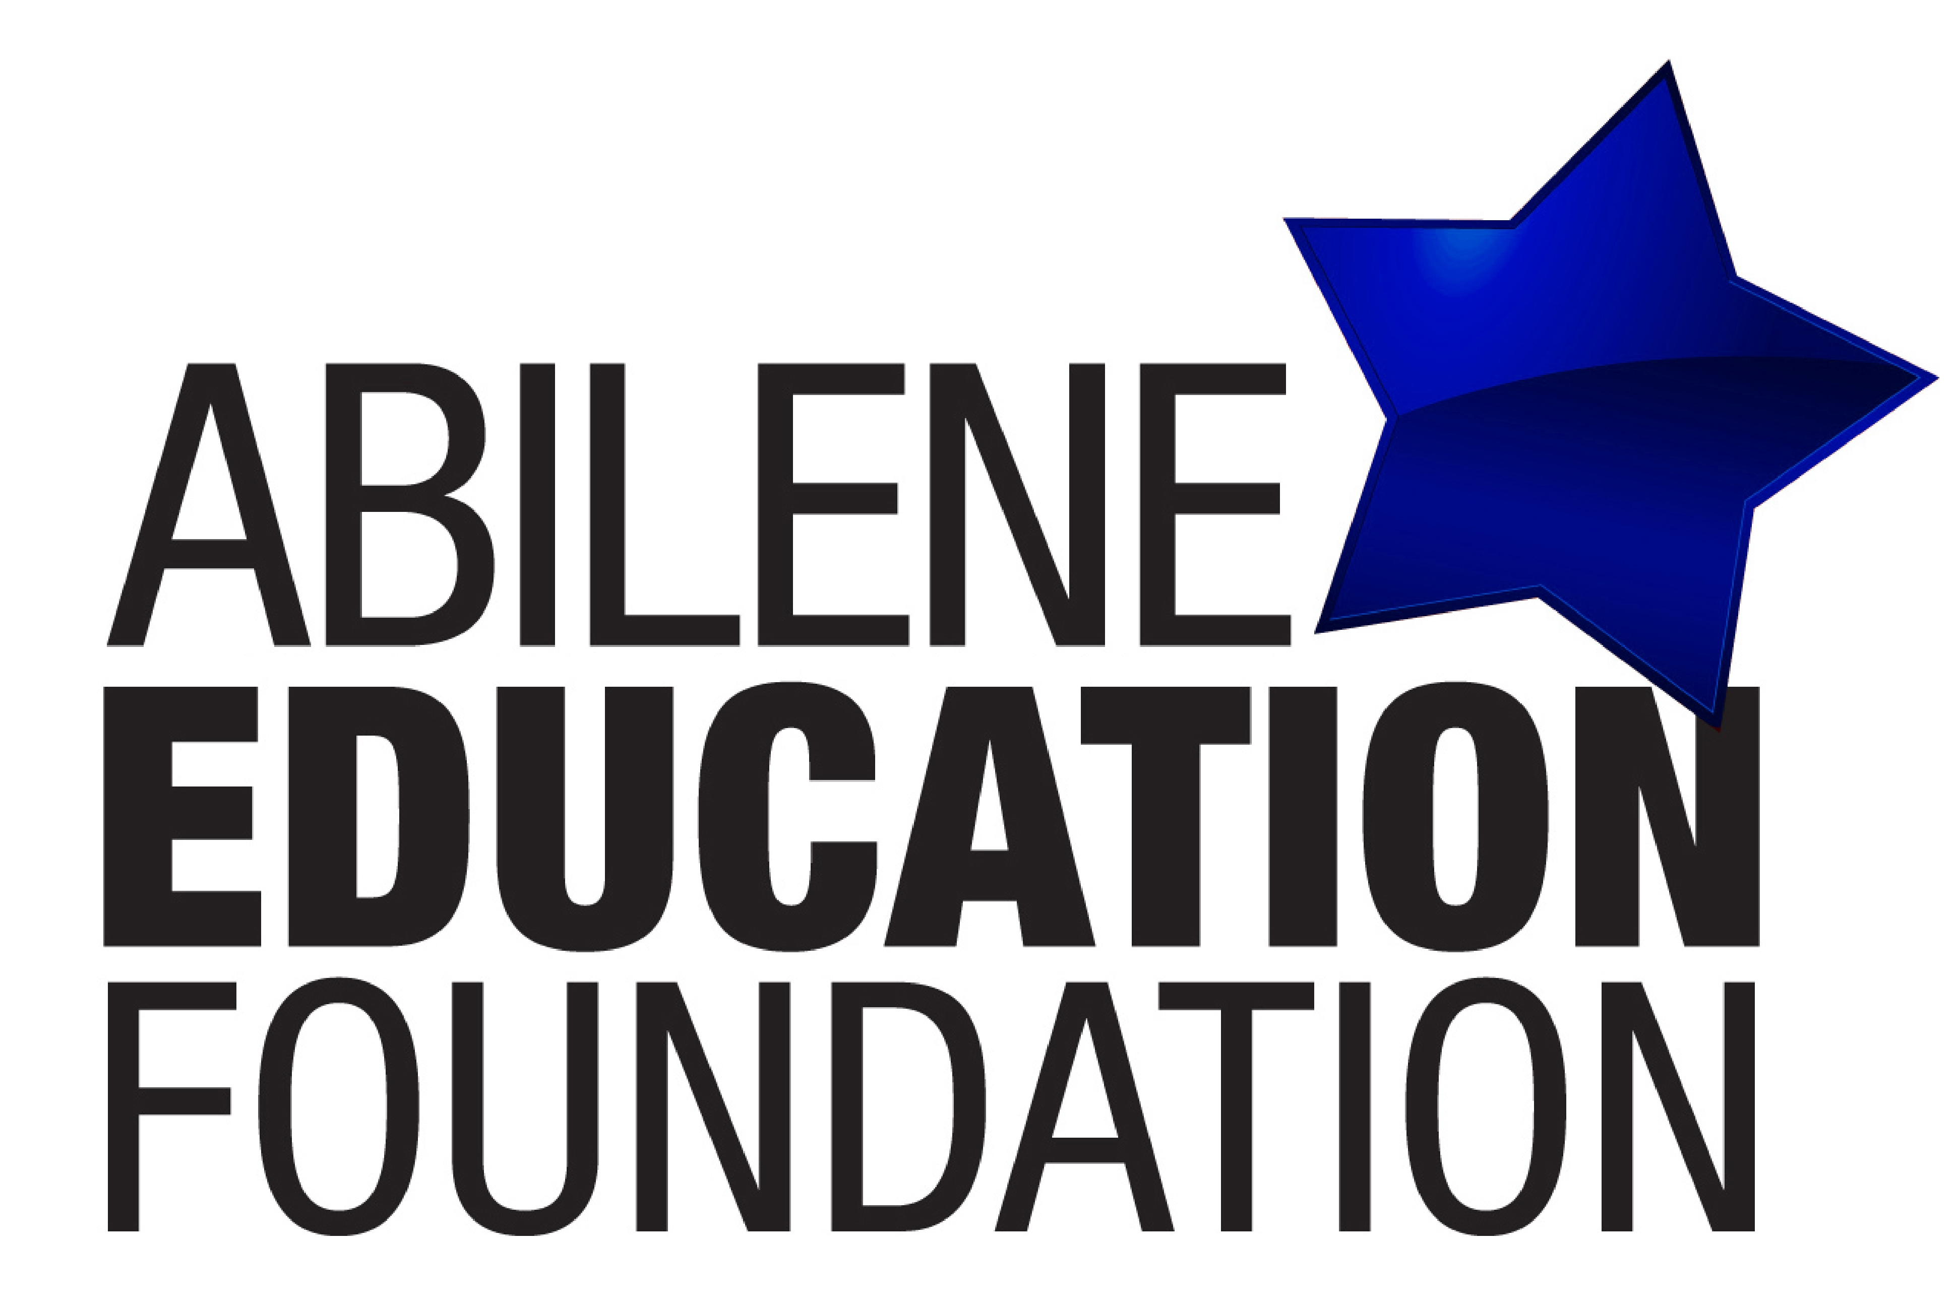

Abilene Education Foundation
Board Meeting Agenda

Thursday, August 24, 2017 * 11:30-1:00 PM
Crockett Room * AISD Administration Building, 241 Pine Street

- Call to Order – Mike Breckenridge, President
- Approve Consent Agenda
- Minutes of the May 2017, Board Meeting

- Financial Highlights – May, June, July 2017 – E.B. Dotson III
- AISD Report, Dr. Abigayle Barton
- Proposed 2017-2018 AEF Budget – E.B. Dotson III & Christine Curtis-Carr
- Nominating Committee – Roland Orr
- Board Member Candidate
- Committee Updates
A. Judy Dudley Memorial GIFT Grants – Mike Dudley
B. Payroll Deduction Campaign/STAR Teacher Grants –
Candy Scarborough & Mike Thomesen
C. COOL – Amanda Wiskow & LaQuiera Gantt

- Executive Director’s Report
- Adjourn
Benefitting the Abilene Independent School District
Are you looking for information from a meeting, upcoming meeting dates/locations or the previous minutes or agenda? Check out the “For Board/Advisory Board Members Section Only” at
www.aaeeff.org/for-board-members/ Password: aef2017

